**The Guidelines for Drone Geophysics: A Progress Report**

Geoff Pettifer, Terra Entheos Geoscience Pty. Ltd., Perth, Western Australia

Ronald S. Bell, Drone Geoscience, LLC, Lakewood, Colorado

Rainer Wackerle, GeoIntrepid / Intrepid Geophysics, Windhoek, Namibia

Tim Archer, Reid Geophysics, Eastbourne, UK

Steven Van der Veeke, Medusa Radiometrics / University of Groningen, Groningen, The Netherlands

Jan Francke, Groundradar, Toronto, Canada

# Abstract

In 2021, the ad hoc **Inter-society Committee on the Guidelines for Drone Geophysics** formed with a mission to ***inform the consumers of drone geophysical data and educate the practitioners and clients using drones to collect the data***. The committee consists of geophysicists from academia, government research organizations, and industry.

The following professional associations actively support the initiative.

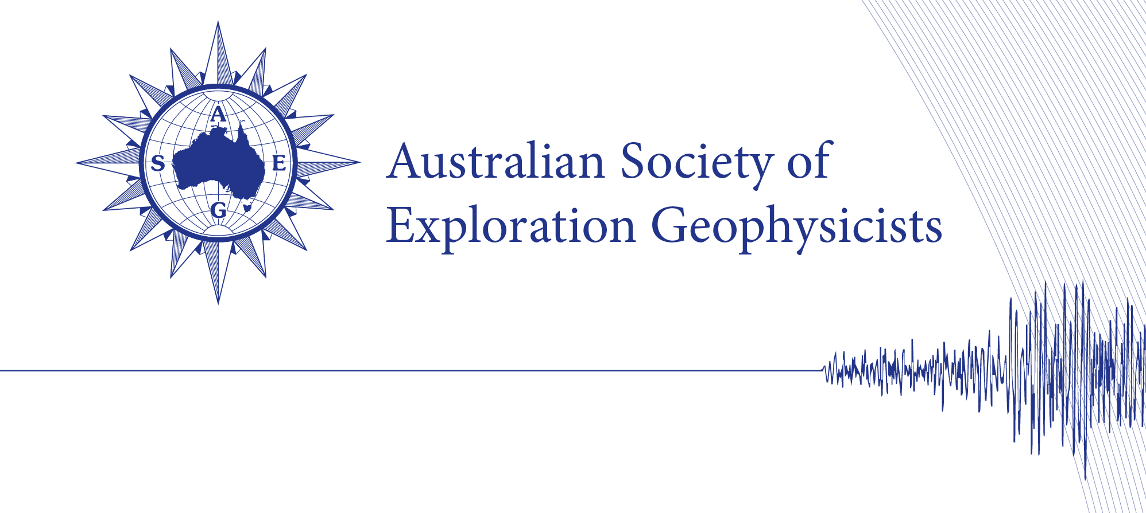

**BC Geophysical Society**



In November 2022, **The Guidelines for Drone Magnetics v 1.0** was published and made available for download at <https://www.guidelinesfordronegeophysics.com/>.

Throughout 2023 and 2024, the drone magnetic guidelines underwent rigorous review and editing by the committee and others. As a result of the investment of time and effort, **The Guidelines for Drone Magnetics v 2.0** is scheduled for release and available for download at the website listed above in April 2024.

Creation of guidelines about the collection of gamma ray spectrometry, electromagnetic, and ground penetrating radar data using unoccupied aerial vehicle (UAV) has been progressing nicely when considered within the context of a initiative founded and fully supported by volunteerism within the professional community and from a widespread of global geoscience Societies. During the presentation, the audience will receive a Progress Report detailing the status of each guideline including details about the accomplishments to date, the tasks that are either in-process or in the queue, and the anticipated date of publication.