Comparison of UAV-borne and Helicopter-borne Gamma Ray Spectrometer
Marshall MacNabb, MWH Geo-Surveys Inc., Reno, NV
Abstract
In July 2022, MWH Geo-Surveys conducted a 3-day experimental UAV Gamma Ray Spectrometry survey at a property in northern Nevada at the request of a mining exploration company. The test survey was conducted in rugged mountainous terrain. The purpose of this survey was to compare the quality and resolution of the Georadis D230A UAV mounted gamma ray spectrometer with data previously collected through a conventional helicopter-mounted spectrometer. The spectrometer configuration used was a dual crystal, 2inch x 2inch BGO detector (volume: 104cm³) mounted underneath a heavy lift UAV. The survey was flown at 20m AGL height over a high-resolution UAV collected DSM with a line spacing of 50m and a nominal speed of 5m/s. Data was processed by MWH and presented as; Total Count, Thorium concentration (ppm), Uranium concentration (ppm), and Potassium concentration (%).
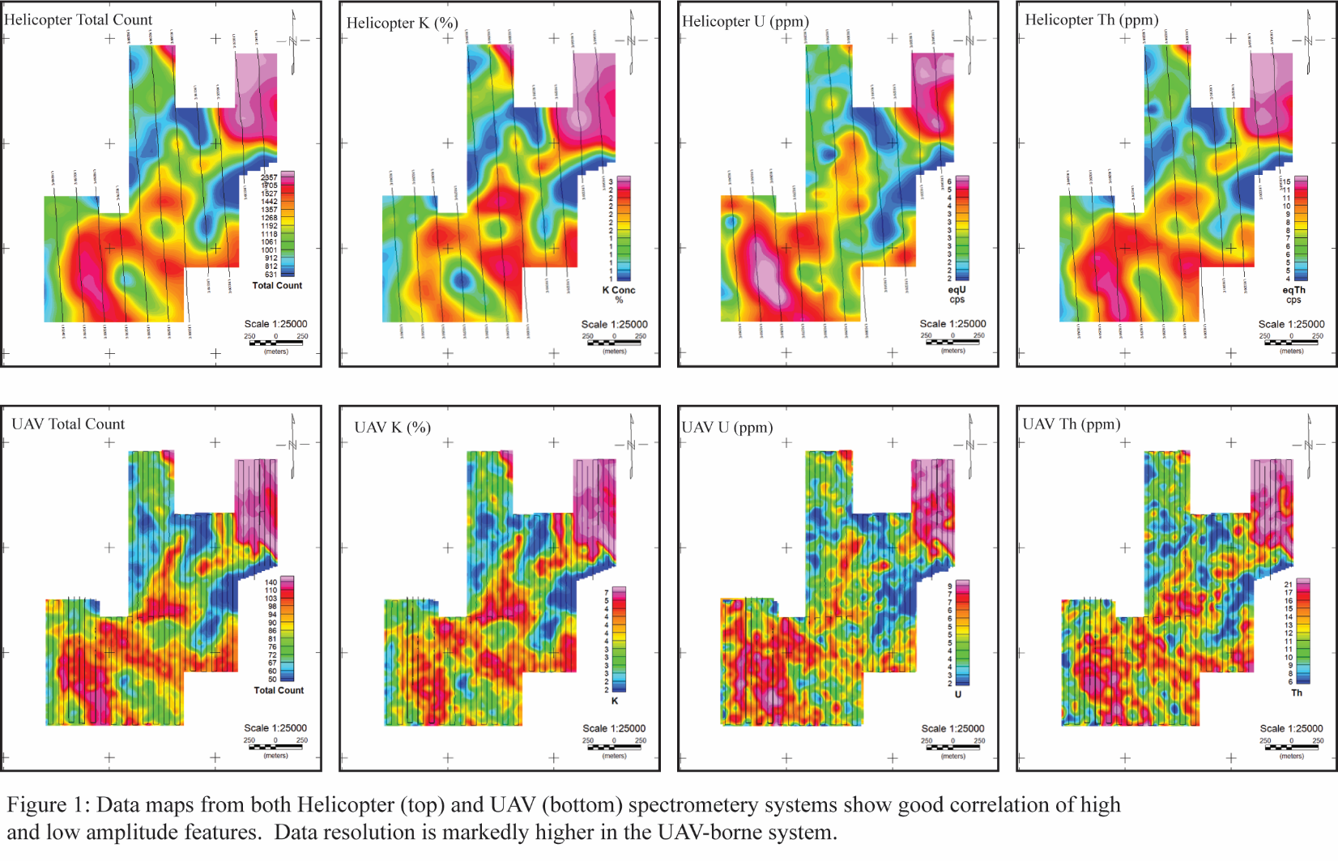
The data comparison maps below show a very strong correlation between the UAV collected data and the helicopter collected data. Total count values of the UAV detector are significantly lower which is expected due to the significantly smaller detector volume. The UAV maps show a higher level of detail in all four data sets. Aside from the closer line spacing (UAV vs. Heli), the increase in definition is more than likely due to a significantly lower terrain follow height, and a slower UAV flight speed.

