**RETRIEVING SUBSURFACE PROPERTIES OF MARS-ANALOG GLACIERS**

**WITH DRONE-BASED GPR**

Roberto Aguilar, University of Arizona, Tucson, AZ

Tyler M. Meng, University of Arizona, Tucson, AZ

Michael S. Christoffersen, University of Alaska, Fairbanks, AK

Stefano Nerozzi, University of Arizona, Tucson, AZ

John W. Holt, University of Arizona, Tucson, AZ

**Abstract**

Martian debris-covered glaciers (DCGs) contain large quantities of water ice buried under a protective layer of rock and dust, as revealed by observations from the Shallow Radar (SHARAD) sounder on NASA’s Mars Reconnaissance Orbiter. However, internal structure and debris layer thickness which are of interest for paleoclimate studies and in-situ resource exploration, respectively, are not obtainable with this instrument and would be challenging for any orbital platform.

On Earth, ground-penetrating radar (GPR) has been employed over terrestrial analogs to understand the basic relationships between the composition, structure, flow kinematics, and morphology of similar landforms. Traditional surface-based GPR involves slow, manual operations with bulky equipment that renders it less suitable than robotic platforms for future Mars exploration missions. To address this challenge, we tested a drone-based GPR over terrestrial DCGs, yielding results that are promising for surveying the interior of Mars-analog glaciers with airborne platforms.

**Introduction**

The Shallow Radar (SHARAD, 15-25 MHz) sounder onboard the Mars Reconnaissance Orbiter has confirmed that the bulk composition of debris-covered glaciers (DCGs) at the mid-latitudes of Mars is nearly water ice(Holt et al., 2008).However, SHARAD has only detected a few internal internal debris layers and cannot provide information about the supraglacial debris thickness. The former can help elucidate glacier evolution and paleoclimate. The latter is also critical for in situ resource utilization (ISRU) of water in future landed missions to Mars (Baker and Carter, 2019).

Studies with ground penetrating radar (GPR) over terrestrial analogs have provided insights into the processes controlling the formation and evolution of Martian DCGs (Petersen et al, 2020; Meng et al. 2023). This geophysical method penetrates through the debris layer on the surface, allowing for the quantification of the debris thickness, total glacier thickness, ice purity, and the presence of englacial bands. Traditional surface-based GPR has a high signal-to-noise ratio (SNR), but it can be a time-consuming and hazardous manual task, since it involves walking on rough and steep surfaces, with some slopes being inaccessible and/or unsafe to traverse.

To overcome these limitations, we integrated a drone-based GPR (DGPR) that consists of a MALA Geodrone 80 GPR system mounted on a DJI Matrice 600 Pro, with a UgCS SkyHub system for automated terrain following. This is a novel approach that hasn’t been tested on DCGs but showcased effective outcomes on alpine glaciers (Ruols et al., 2023)**.** We tested our DGPR at two DCGs: Sourdough, Alaska in July 2022, and Galena Creek, Wyoming in August 2022 and August 2023. At these two sites, we have surface-based GPR data at different center frequencies (50 MHz, 100 MHz, and 200 MHz), allowing for analyses over a range of vertical resolutions.

The goal of this study is to explore the capabilities of a robotic radar platform for retrieving the subsurface properties of Mars-analog glaciers. We compare the results of debris thickness, total glacial thickness, and detection of internal bands with existing surface-based GPR, increasing the total coverage by generating grids and flying over inaccessible areas on foot.

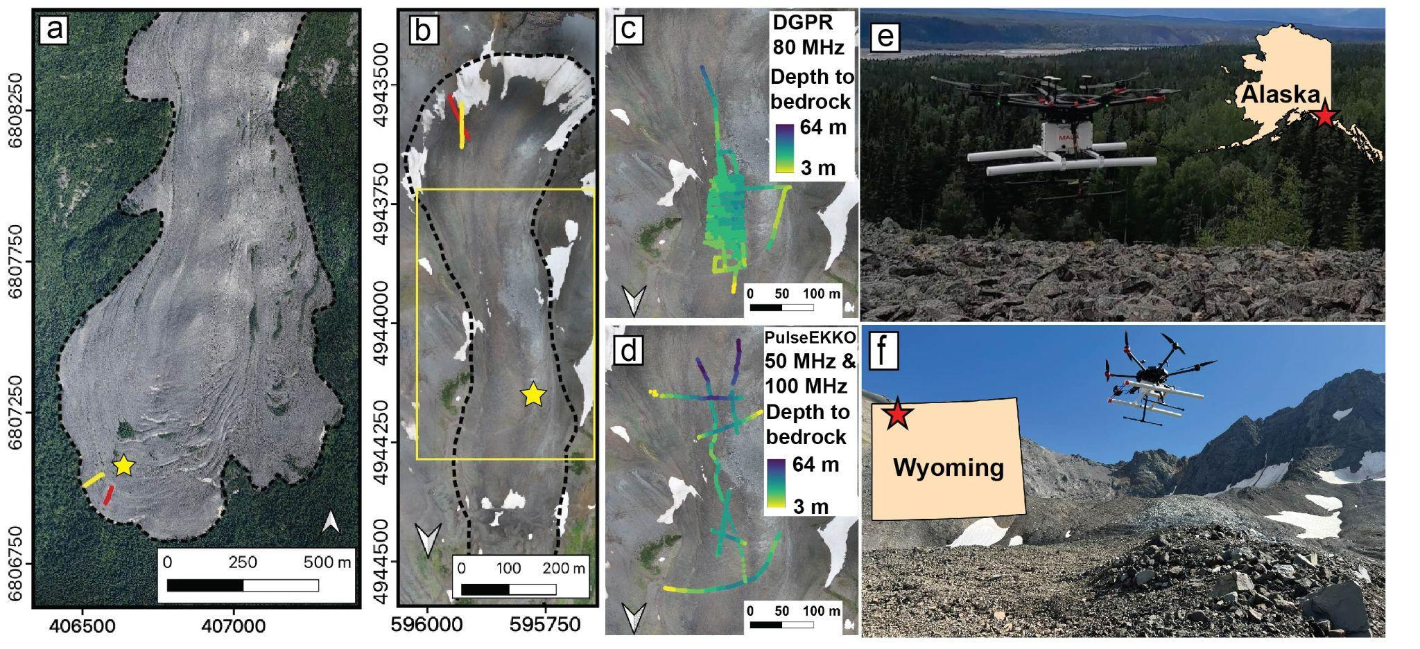

**Figure 1**: Maps and photos of the study sites. **(a)** Sourdough, Alaska, airborne imagery acquired in July 2022, projected to WGS 84/ UTM Zone 7N. **(b)** Galena Creek, Wyoming, drone imagery acquired in August 2023, projected to WGS 84/ UTM Zone 12N. Ground tracks for Figures 2 and 3: yellow lines for DGPR acquisitions and red lines for surface-based GPR acquisitions. **(c) and (d)** Depth to bedrock at Galena Creek obtained with the DGPR (80 MHz) and surface-based GPR (50 MHz and 100 MHz), respectively. Locations shown in yellow box in (b). **(e)** DGPR operations at Sourdough, Alaska, location marked with a star in (a). **(f)** DGPR operations at Galena Creek, Wyoming, location marked with a star in (b). The GPR MALA Geodrone 80 (white box) is mounted on the DJI M600 Pro drone. The length of the antennas is 1.04 m, with a separation of 0.53 m.

**Study sites**

Sourdough Rock Glacier, situated in the Wrangell Mountains, Alaska, spans approximately 3 km in length and 1 km in width, with an elevation ranging from 550 to 1400 m above mean sea level (amsl). Surface-based GPR measurements observed a total thickness of ∼40 m with a bulk composition greater than 50% ice and a supraglacial debris thickness of ~2 m (Meng et al. 2023).

Galena Creek Rock Glacier is an ice-cored DCG located in the Absaroka Mountains of northern Wyoming. It is 1.6 km long by 300 m wide, and its elevation ranges from 2700 to 3200 m amsl. The GPR data have revealed a total thickness ranging from 30 to 55 m in the cirque and also identified englacial debris bands. These bands are incorporated into the debris-facilitated ice accumulation model, which is hypothesized to contribute to the formation of this DCG (Petersen et al., 2020).

**Methodology**

The MALA Geodrone 80 GPR has dipole antennas with an impulse centered at 80 MHz and approximately 40 MHz bandwidth. To maintain a constant speed and altitude over an uneven surface, we use a UgCS SkyHub terrain-following system consisting of an altimeter and a distance sensor for obstacle avoidance. The GPR antennas should be as close to the ground as possible to maximize the SNR. We have conducted tests starting at 1.5 m above the ground; however, due to the roughness of the terrain, steep slopes, and the presence of large boulders, most of the surveys have been performed at altitudes between 2 and 3 m to reduce the risk of collision. These surveys were flown at a speed of 1 m/s with an along-track sampling rate of 0.25 - 0.1 s.

We have developed a methodology for direct comparison with the surface-based GPR data from Sensors & Software PulseEkko. First, we apply a background subtraction with a sliding mean fast Fourier transform function to remove the background noise caused by the drone and the GPR itself. Then, we use radar processing software to manually pick the ground surface, the debris-ice interface, the englacial layers, and the basal unit. Examples of these pickings are shown in Figure 2. Finally, to convert the one-way travel time into depth, we use the electromagnetic wave speed obtained from existing common midpoint (CMP) surveys (Petersen et al, 2020; Meng et al. 2023). A valid alternative to determine the wave speed can be by hyperbola fitting.

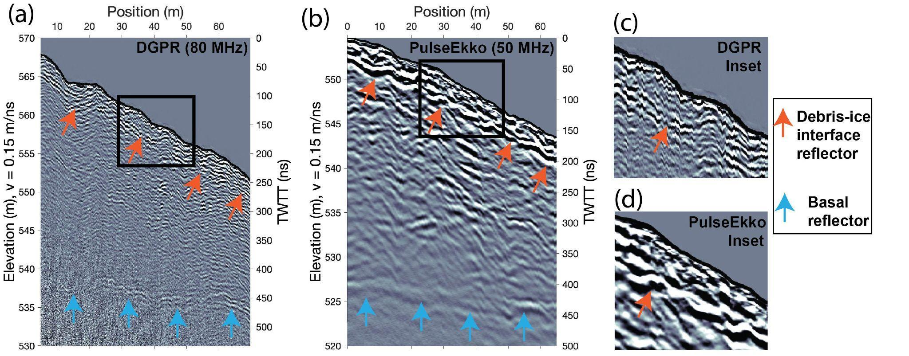

**Figure 2:** Radargrams acquired at lower Sourdough Rock Glacier. **(a)** Drone GPR at 80 MHz, ground tracks represented with the yellow line in Figure 1a. **(b)** Surface-based PulseEkko GPR at 50 MHz, ground tracks represented with the red line in Figure 1a. **(c) and (d)** areinsets of the debris-ice interface from Figure 2a and Figure 2b, respectively.

**Experiments and results**

In the lower section of Sourdough, we detected with the DGPR a debris thickness of up to 2 m, and a total glacier thickness of between 15 and 22 m (Fig 2a) towards the terminus of the glacier. This is consistent with the results obtained with the surface-based GPR (Fig 2b).

At the middle section of Galena Creek, we generated a basal thickness map with all the acquisitions available from the DGPR (Figure 1c) and surface-based GPR (Figure 1d). Results from the DGPR are consistent with surface-based GPR, increasing coverage density with grids, and obtaining data over sections that couldn’t be traversed on foot (bottom section). However, in the top section, reflectors deeper than 40 m were only observed with the surface-based GPR. This is due to a limitation in the penetration depth of the higher frequency used by the DGPR. This may also be related to geometric spreading during transit in air, and loss at air-rock surface interface.

Finally, in the cirque of Galena Creek, we conducted drone surveys where englacial debris bands had been identified with surface-based GPR (Petersen et al., 2020). The DGPR didn’t detect sections of each internal reflector when they were intersecting the surface. However, as they dipped down and the slope angle relative to the surface was smaller, the signal from these englacial debris bands was received (Figure 3). This will require further studies on the slope resolvability of englacial layers (Castelleti et al., 2019) or antenna directivity (Langhammer et al., 2017). Additionally, we observed that the top dipping reflector was deeper on the DGPR (Figure 3a) than on the surface-based GPR radargram (Figure 3b). This discrepancy arises because the drone flew over a section covered with snow, while the surface-based GPR avoided the snow-covered area. Our interpretation is that the top dipping reflector from DGPR radargram is the interface between the snow and the supraglacial debris.

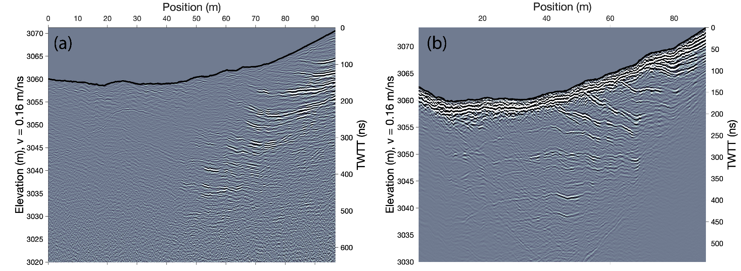

**Figure 3:** Radargrams with dipping reflectors in the upper cirque of Galena Creek Rock Glacier. **(a)** Drone GPR at 80 MHz, ground tracks represented with the yellow line in Figure 1b. **(b)** Surface-based GPR at 50 MHz, ground tracks represented with the red line in Figure 1b.

**Conclusions**

We successfully employed a DGPR platform to survey terrestrial DCGs, resolving debris-ice contacts, internal glacier stratigraphy, and total glacial thickness. Moreover, this system can detect these interfaces over larger areas, with higher coverage density, and in less time than surface-based GPR. The DGPR platform and our results over Martian analog ISRU targets demonstrate the potential for drone-based planetary exploration with radar sounding.

**References**

[Baker, D. M. H. and Carter L. M., Feb. 2019, Probing supraglacial debris on Mars 1: Sources, thickness, and stratigraphy, Icarus, vol. 319, pp. 745–769](https://www.zotero.org/google-docs/?W05ykB).

Castelletti, D. at al., Dec. 2019, Layer Optimized SAR Processing and Slope Estimation in Radar Sounder Data, J. of Glaciology 65, 254, 983–88.

[Holt, J. W. *et al.*, Nov. 2008, Radar Sounding Evidence for Buried Glaciers in the Southern Mid-Latitudes of Mars, *Science*, vol. 322, no. 5905, pp. 1235–1238.](https://www.zotero.org/google-docs/?W05ykB)

[Meng, T. M. et al., Jun. 2023, Rock glacier composition and structure from radio wave speed analysis with dipping reflector correction, *J. Glaciol.*, vol. 69, no. 275, pp. 639–657](https://www.zotero.org/google-docs/?W05ykB).

P[etersen, E. I. et al., Feb. 2020, New insights into ice accumulation at Galena Creek Rock Glacier from radar imaging of its internal structure,” *J. Glaciol.*, vol. 66, no. 255, pp. 1–10](https://www.zotero.org/google-docs/?W05ykB)**.**

[Ruols, B. et al. Nov. 2023, Development of a drone-based ground-penetrating radar system for efficient and safe 3D and 4D surveying of alpine glaciers,” *J. Glaciol.*, pp. 1–12](https://www.zotero.org/google-docs/?W05ykB).

Langhammer, L. et al., May 2017, Ground-Penetrating Radar Antenna Orientation Effects on Temperate Mountain Glaciers. Geophysics 82, no. 3.

**Acknowledgments**

We thank the field assistance provided by Rocío Jacobo, Michael Daniel, Rishi Chandra, Daniel Thomas, Nathaniel Putzig, Aaron Russell, and Callum Walter at Galena Creek, Wyoming, and by Bruno Belotti at Sourdough, Alaska. We also thank Eric Petersen for providing the GPS coordinates of existing surface-based GPR data at Galena Creek.