Colorado State University - Subsurface Imaging Technology Test Site (SITTS): A Multidisciplinary Facility for Near-Surface Methods

Alex Olsen-Mikitowicz, Colorado State University Drone Center, Fort Collins, Colorado
Christopher Robertson, Colorado State University Drone Center, Fort Collins, Colorado
Ronald S. Bell, Drone Geoscience, LLC, Lakewood, Colorado

Abstract
We present the Subsurface Imaging Technology Test Site (SITTS), an innovative new facility at Colorado State University strategically located at Christman Airfield in Fort Collins, Colorado. Designed for testing and validating geophysical and remote sensing technologies, SITTS will be tailored to the employment of remotely operated airborne and terrestrial vehicles in addition to traditional methods. With FAA designation for Uncrewed Aerial Systems (UAS) testing, SITTS is uniquely suited for airborne applications in near-surface geophysical imaging and large area surveys. Catering to researchers and students in the fields of geophysics, geology, anthropology, soil science, engineering, et al., the facility will serve as a hub for interdisciplinary learning and engagement. Beyond academia, industry partners are invited to test platforms and sensors, refine training methods, and collaborate on the development of best practices. Operated and managed by the Colorado State University Drone Center, this initiative aims to foster cooperation between academia and industry, propelling advancements in geophysics and remote sensing methods, practices, and technologies.
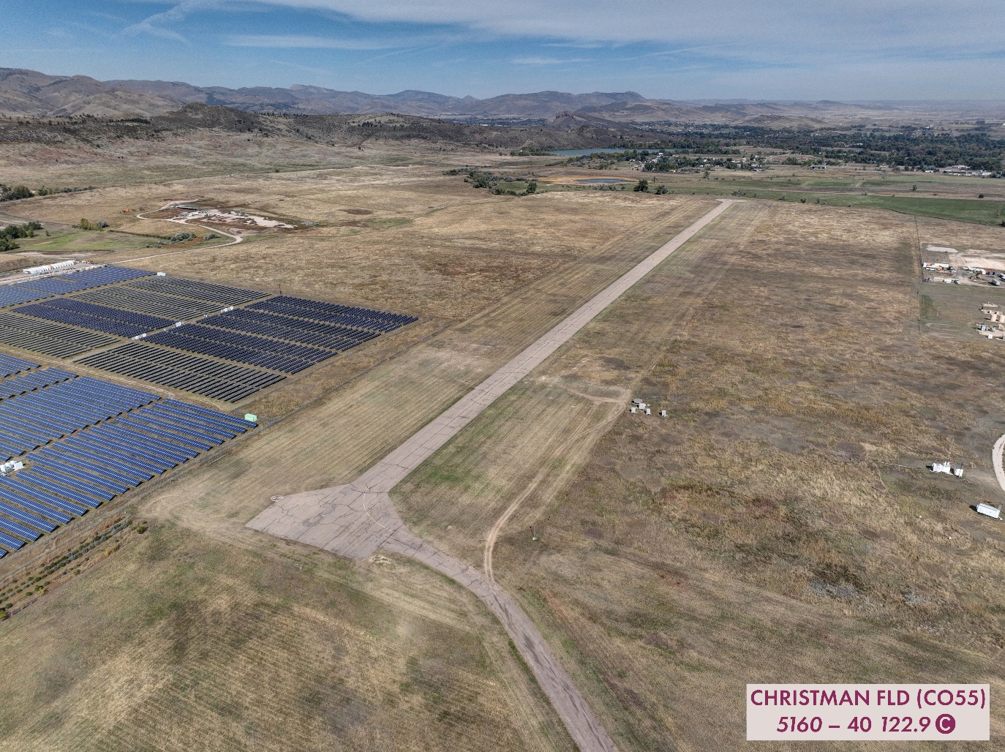
Figure 1: Christman Airfield in Fort Collins, Colorado, overseen by the Colorado State University Drone Center, will serve as the host the new Subsurface Imaging Technology Test Site (SITTS). This unique site is dedicated to advancing education, fostering research and development, and testing both ground and aerial geophysical methods.

