Study on hydraulic conductivity characteristics of fault zone in waste disposal based on ERT

Fan Jing, Zhaotong University, Zhaotong, China

Wentao Xu, Nanjing University, Nanjing, China

Xiaozhao Li, State Key Laboratory for GeoMechanics and Deep Underground Engineering, China University of Mining and Technology, Xuzhou, China

Xiyong Wang, CNNC Key laboratory on Geological Disposal of High-level Radioactive Waste, Beijing Research Institute of Uranium Geology (BRIUG), Beijing, China

Xiaodong Ma, Department of Earth Sciences, ETH Zürich, Zurich, Switzerland

Wei Zhang, Nanjing University, Nanjing, China

Abstract
Deciphering the internal composition of large-scale fault zone is a prerequisite for constructing conceptual models of fault zone architecture and is essential for a proper understanding of the seismological, mechanical and hydrological properties of fault. To this end, we conducted fine detection and interpretation of a large-scale fault (F31 fault) in the first Chinese underground research laboratory construction (URL) site for high-level radioactive waste geological disposal repository to elucidate the fault zone architecture. The fault, located in the west of the URL site, is an approximately 5.5-km scale steeply dipping normal fault extending continuously in a straight line. In this study, geophysical prospecting techniques including high-density electrical resistivity tomography (ERT) and reflection seismic tomography (RST) were employed to investigate and interpret the subsurface architecture of the fault zone along the strike of fault core and perpendicular to fault core, respectively. In addition, a 4-m long three-dimensional prospecting trench was excavated manually to observe the geological structure characteristics of the fault zone. Geophysical exploration results suggested that the shallow surface within the fault zone, which is mainly characterized by low conductivity and low wave velocity transmission medium, shows complex geological characteristics due to severe weathering, while the relatively complete bedrock lies beneath the overburden layer. Along the fault strike, the bedrock is buried shallowly at the south of the fault zone. In contrast, at the north, it is mainly characterized by a thick weathering layer overlying the bedrock. For the detection results of vertical fault core, both geophysical methods have deciphered the location of the fault core and the spatial distribution characteristics of F31 fault zone. However, compared with RST results, ERT also clearly diagnosed that there is another secondary fault zone with a certain scale at the hanging wall of F31 fault. In terms of the F31 fault core, ERT suggested that the fault dips about 70° NW and the width of the fault core is 2~5 m, which is consistent with the results of the 280°∠75° discontinuities and the approximately 2.6-m long fault core revealed by the prospecting trench. This results provide an important basis for further understanding the internal structure of faults in this site and the avoidance design of the fault-affected range for the underground engineering layout.
Keywords: Underground research laboratory (URL); Geological disposal; Fault zone architecture; Electrical resistivity tomography; Reflection seismic tomography

1. Introduction
Faults, as large-scale discontinuities, play an important role in controlling regional stability, migration of crustal fluids, hydrocarbon reservoirs and mineralization mechanism. Under the action of geological movement and crustal stress, the fault zone formed by compression and dislocation often presents complex subsurface architecture (Valoroso et al., 2014; Fialko and Jin, 2021; Wang et al., 2021; Wu et al., 2021). The complex mechanical behavior and hydraulic behavior within the fault zone, in turn, determine the nature of the fault zone, which has the potential to lead to significant changes in the characteristics of these discontinuities (Caine et al., 1996; Hardebeck et al., 1999; Faulkner et al., 2003; Ishibashi et al., 2014; Ishii, 2017, 2021). For example, some faults under the condition of critical stress state are easily induced by activation factors such as earthquake and pore water pressure, which will activate the “sleeping” faults and cause the possibility of large-scale geological disasters (Faulkner et al., 2006; Zhang et al., 2021; Zhang and Ma, 2021). Given the complex deformation mechanism and diagenesis, the hydrocarbon reservoirs related fault zones might seal in some areas but leak in other areas (Renard and Marsily, 1997). Similarly, due to the complexity and heterogeneity of fault zone structures, faults cannot simply be considered as barriers or channels for fluid flow or groundwater (Caine et al., 1996; Hardebeck et al., 1999; Odling et al., 2004; Fang et al., 2018). Therefore, the demand for detailed understanding of geological architecture of fault zone structure is increasing not only in theoretical basis research but also in engineering practice production. However, insufficient understanding of the detailed geological structure characteristics in and around the fault zone hampers our further investigation of these scientific issues.
To date, the recognition of fault zone structure mainly relies on geologists’ direct observation in the field and collecting typical representative analogues of active or mature faults and geological evidence (including fault breccia, fault gouge, joints, veins, fault striation, damage-zone and deformation bands) for empirical analysis (Smith et al., 2013; Valoroso et al., 2014; Chen et al., 2022; Rupnik et al., 2022). Graham et al. (2003) conducted an innovative study on the normal faults in the leading thrust front of Maiella Mountain, Italy, that is, through field mapping, they documented the detailed geological architecture of these faults as the slip values of faults increasing from a few millimeters to tens of meters, and concluded the four stages of fault development. Through detailed mapping on aerial photos and field outcrop investigation, Bonson et al. (2007) discussed the heterogeneity in structure and content of Maghlaq Fault, Malta, and speculated the potential impact of underground fluid flow on fault architecture. Shipton and Cowie (2001) studied the evolution and growth of fault zones as a four-dimensional system, taking into account the time dimension, by making detailed geological maps of throw variations and deformation characteristics of two km-scale normal faults. These studies had achieved exciting results and promoted the intuitive recognition of fault zone architecture, a complex geological structure. However, for field studies, the active deformation on large-scale faults is usually accompanied by poor geological exposure, which makes the description of the geological structure characteristics of large-scale faults very limited, and the field work is often hampered.
Geophysical techniques have opened a window for in-depth study of the large-scale fault zone structure and the fault surrounding rock damage zone (Schulz et al., 2000; Kneuker et al., 2017; Lesage et al., 2019; Ho et al., 2020; Chen et al., 2022). The seismic method was developed by using the difference in the speed of waves as they travel through different underground media. Long and Imber (2012) successfully captured the deformation and displacement characteristics inside the fault zone according to the seismic reflection profile by using a high-resolution 3D seismic survey technique. Based on the sensitivity of electromagnetic waves to different rock properties (dielectric impedances between main rock and faults), Ma et al. (2022) used ground-penetrating radar in both single-hole and cross-hole configurations to perform geophysical imaging of the rock mass in Bedretto Lab, Switzerland and obtain the spatial distribution of underground fault zones. For different underground dielectric materials with different conductivity, Electrical resistivity tomography technique has attracted the favor of many scholars. Štěpančíková et al. (2011) used ERT technique to conduct geophysical investigation on the Sudetic Marginal Fault zone in the Bohemian Massif, and determined the exact locations of the regional main faults according to the resistivity distribution. Recently, Sapia et al. (2021) employed ERT technique to detect the internal geological structure of the Pian Grande di Castelluccio basin in central Italy and provide a 3D resistivity image, so as to provide insights into the long-term evolution, interaction and segmentation of the complex fault systems along the basin boundaries. Thus, geophysical exploration methods have advantages in forward and inverse imaging of underground geological structures, especially internal structures of fault zones.
As reported in previous studies, Beishan area in Gansu province, as the construction site of the first underground research laboratory (URL) for geological disposal of high-level radioactive waste in China, is surrounded by multiple large-scale faults (Wang et al., 2018; Xu et al., 2020, 2021). Therefore, challenges with respect to the recognition of the mechanical behaviour of fault zones, the stability of the site under the influence of these faults and the scientific evaluation of groundwater migration field are particularly highlighted. However, the fine detection and recognition of the geological structure of the fault zones is the prerequisite for investigating these scientific problems and address engineering concerns. The purpose of this paper is to use geophysical exploration techniques (resistivity imaging method and seismic wave method) to perform fine detection of the internal architecture of the km-scale F31 fault through survey lines deployed along the strike direction of the fault core and perpendicular to fault core direction. Finally, the field observations from a man-made prospecting trench in the F31 fault core are compared with geophysical observations of geological structure inside the fault zone.

2. Study area and geological setting
The area under investigation is located in the Beishan area of Gansu Province in northwest China. As reported in the previous study (Wang et al., 2018), this unique and typical area, Xinchang site, is composed of gneiss biotite monzonite and biotite granodiorite rock mass, which is mainly formed by granite intrusion. The rock mass in this area is simple and the tectonic background is relatively stable, so it is a good natural candidate site for nuclear waste disposal repository. The region is characterized by a typical continental arid climate, with dry and windy, and large evaporation (about 3100 mm/year) and little precipitation (about 80 mm /year). Xinchang rock mass, covering an area of approximately 94 km², is distributed in the form of east-west direction, with a length of approximately 20 km from east to west and a width of approximately 5 km from north to south (Fig. 1a). The geological structure in this site is complex. The geological investigation shows that there are 13 large fault structures, among which the NNE-EW-trending fault structures is dominant, followed by the NE-trending faults (Fig. 1a). The two typical structures near the URL construction site are F31 fault and F32 fault, which belong to grade I faults with a length of more than 5 km (Figs. 1b and 1c). F31 fault, located in the west of URL site, is a typical normal fault (Fig. 1b). The fault core was seriously broken by strong shearing and weathering action, which is mainly characterized by weathered mixture of soil and rock, and a large number of shrubs grow (Figs. 1b and 1c). These weathering geological features hinder our further understanding of the internal structure of the fault zone. Although the geological structure of the whole region is in a stable state, the existence of these faults still causes people’s concern. Therefore, the fine detection of such large-scale geological structures is quite important for the safe disposal of nuclear waste in the future and also has great engineering geological value.
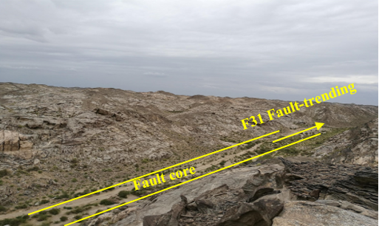
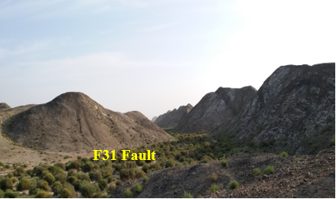
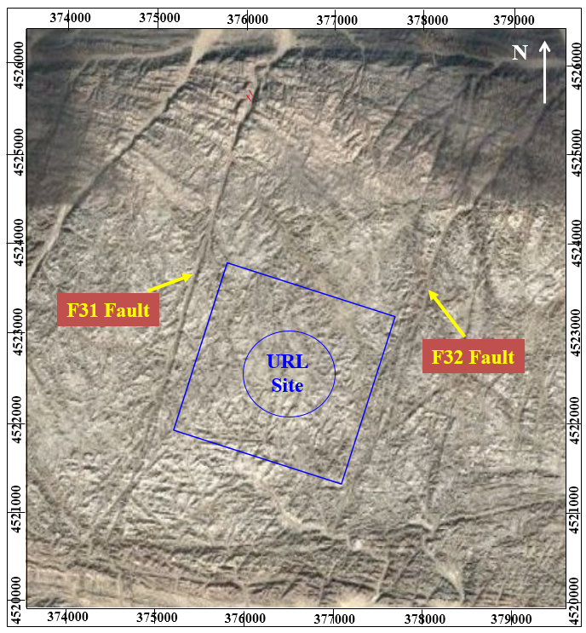
(c)
(b)
(a)
Figure 1: Satellite map of Xinchang site and true scene of F31 fault. (a) Satellite image of Xinchang site; (b) Close view of F31 fault core; (c) Perspective view of F31 fault.

3. Methodology and scheme
Combined with the actual topography and geomorphology of F31 fault in the Xinchang site, high-density direct-current parallel electrical method and multi-channel transient surface wave method were adopted to comprehensively analyze the fault geological structure characteristics and lithology combination characteristics through the collected resistivity value and surface wave characteristic value.

3.1. Electrical resistivity tomography
Electrical resistivity tomography (ERT), as a kind of geophysical nondestructive detection technology, is widely used in the detection of underground geological structures. Because different media have their own corresponding conductivity/ resistivity, the regional structure characteristics that cannot be observed directly can be retrieved by capturing the conductive properties of these media. Considering the accuracy of shallow detection and the reliability and effectiveness of deep detection signals, network parallel electrical acquisition technology is usually adopted. The principle of this technology is consistent with that of conventional high-density resistivity exploration method, that is, power is supplied to the ground through power supply electrodes A and B to form a power supply circuit, and electrodes M and N form a measurement circuit to collect resistivity data. For field measurement, the most common working modes of network parallel electrical method are pole-pole (AM) with single-pole power supply and dipole-dipole (ABM) with dipole power supply according to the configuration of conductive electrodes. As ABM method takes a lot of time in field measurement, especially for large-scale site measurement, this study adopts the AM method. The principle of AM multi-electrode and multi-channel data acquisition system is shown in Fig. 2.
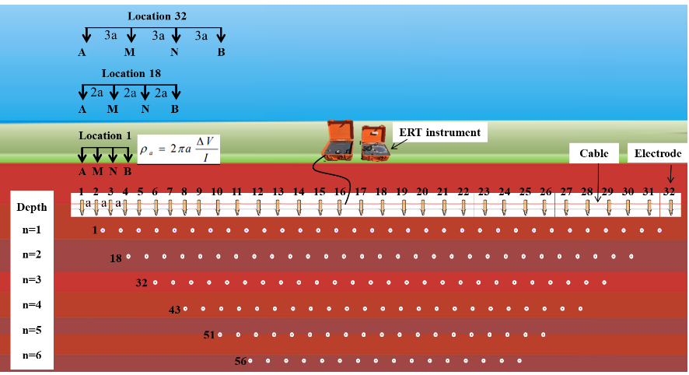
Figure 2: ERT technical schematic diagram

3.2. Reflection seismic tomography
Shallow seismic reflection wave exploration (reflection seismic tomography, RST), as another advanced geophysical method, uses the elastic difference of the medium to detect the geological structure characteristics. In this study, the multi-channel transient surface wave prospecting method, which is characterized by its simplicity, speed and intuitive results, was employed to detect shallow geological structures of F31 fault. RST method, according to the characteristics that the amplitude of Rayleigh surface wave attenuates with depth and the energy is basically limited to one wavelength range, reflects the change of geological conditions in the horizontal direction through the surface wave propagation characteristics of the same wavelength, and reflects the geological conditions at different depths through the surface wave propagation characteristics of different wavelengths (Fig. 3). During field measurement, a transient excitation force is generated by hammering at the ground to form a broad frequency ground roll wave (R wave). These R waves of different frequencies are superimposed and propagate outward in the form of pulse signal. When a multi-channel low-frequency detector receives the pulse vibration signal, the data is collected and the spectrum is analyzed (amplitude spectrum and phase spectrum) to obtain the surface wave velocity with different frequencies and reflection interface depth.
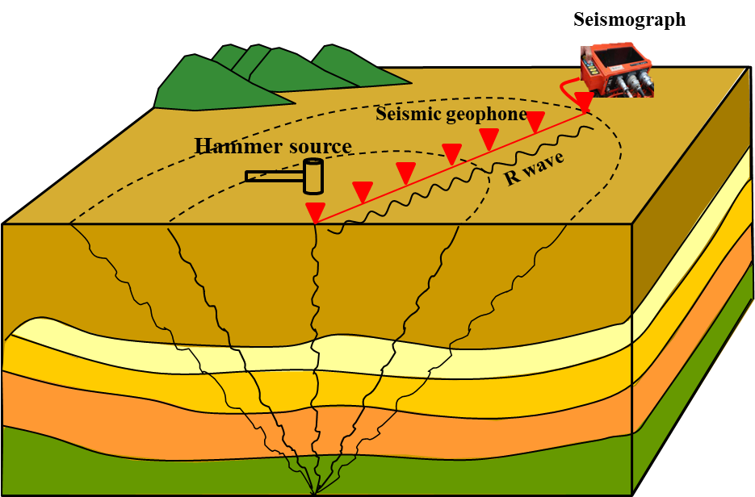
Figure 3: RST technical schematic diagram

3.3 Geophysical detection scheme
Based on UAV aerial photography and on-site geological survey of F31 fault, one ERT detection line and one RST detection line were deployed along the fault core and perpendicular to fault core respectively (Fig. 4a). To obtain the geological structure of the fault as abundantly as possible, the total length of the ERT survey line along the fault strike direction is 1995 m, and the length of the RST detection line is 950 m. In the direction of vertical fault core, the length of ERT measurement line is 950 m, and the length of RST detection line is 770 m. The layout diagram of the detection scheme is shown in Fig. 4a. The specific layout on site are shown in Fig. 4b.
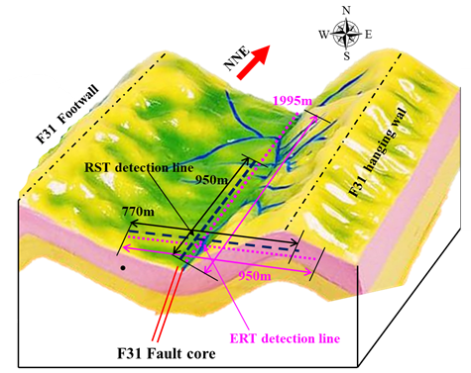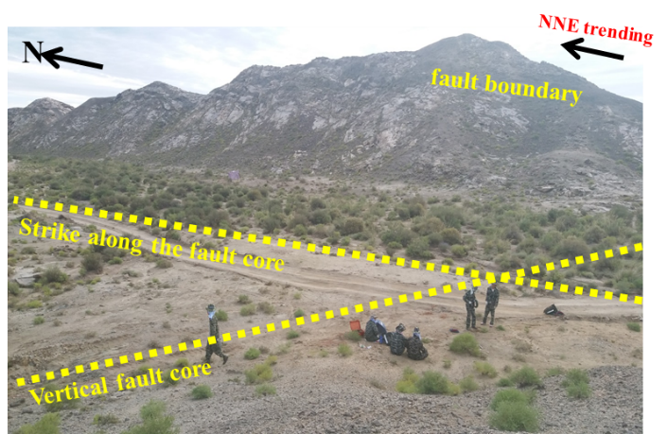
(a)
(b)
Figure 4: Geophysical survey line layout. (a) Overall survey line layout scheme, (b) survey lines layout of parallel and perpendicular to F31 fault, and (c) field data acquisition.

The distributed multi electrode WBD network parallel electrical prospecting instrument, including 2 data acquisition cables (each with 32 electrode channels to supply power current and observe potential difference at the same time), was employed to conduct ERT detection. The maximum layout spacing of each two measuring electrodes is 5 m, and each measuring station can use a maximum of 64 electrodes, so the maximum effective distance of each detection is 315 m. Obviously, for the large-scale geological structure (fault) investigated in this paper, one-time detection distance is not enough. Therefore, in order to ensure the detection of the fault boundary and the maximum depth of the fault core, we adopted the multiple stations overlapping scheme to collect raw data, as shown in Fig. 5. That is, the following measurement was rolled forward on the basis of the previous measurement, with 8 or 16 overlapping electrodes between two each measurements (the corresponding repeated measurement area is 35 m or 75 m in length).
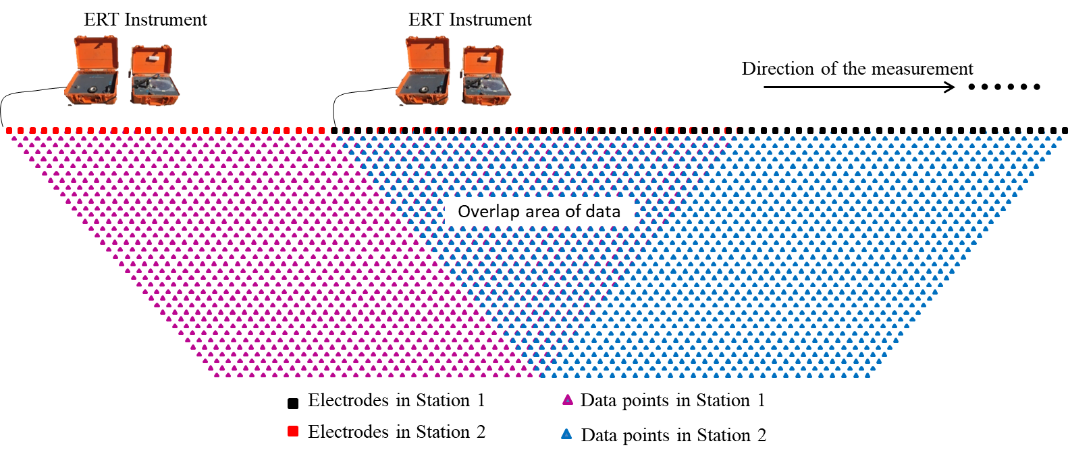
Figure 5: Schematic diagram of roll-along schedule for long-distance measurement

It should be noted that, for ERT detection, two stainless steel electrodes with a diameter of 8 mm and a length of 30 cm were used as power supply electrodes, and copper excitation polarization electrodes with the same specifications were used as measurement electrodes. In addition, during the process of measurement, the satellite GPS locator was used to accurately locate each measuring electrode to obtain the 3D geographic information consistent with the actual terrain, so as to ensure the 3D inversion of fault structure in accordance with the actual terrain conditions.
For multi-channel transient surface wave exploration, Geopen-Miniseis24 integrated engineering seismic detector was used to conduct RST detection. This is an intelligent seismic data acquisition system integrating data acquisition and data processing/interpretation (Fig. 3). It has 24 broadband signal input channels, with a maximum sampling rate of 25 µs and a dynamic sampling range of 131dB. In addition, given the portability and low power consumption, this device is ideal for field work in harsh conditions. During the detection process in this study, the geophone spacing was 3 m, the weight drop seismic source is generated at each measuring point by hammering with a 5 kg hammer on a plate, and then the data was collected dynamically at a frequency of 0.2 ms.

4. Results and analysis

4.1 ERT results analysis
Data measurement on large-scale survey lines is not completed at one time, but collected via multiple measurements with multiple progressive sites. Therefore, in the connection processing of the collected data, we take the average value of two adjacent detection stations as the measurement value of the repeated area (Fig. 5). In the inversion calculation of resistivity imaging, fine uniform square grid division scheme was used in the main imaging region, large uneven grid division scheme was adopted outside the imaging region (boundary region), and the grid cells were gradually increased from inside to outside. This grid partitioning scheme not only ensured the calculation accuracy in the imaging region, but also reduced the workload of large-scale calculation.
For the data collected from the longitudinal electrical detection line deployed along the strike of F31 fault core, the resistivity distribution was obtained via inversion calculation, as shown in Fig. 6. From the south to the north, the elevation of the terrain keeps decreasing, which is consistent with the terrain characteristics of the Xinchang site (high in the South and low in the North). Geophysical inversion indicates that the resistivity changes sharply with low value in the shallow surface, and the resistivity gradually increases with increasing distance from the ground (that is, the buried depth of the rock stratum). In addition, in the overall detection area, the spatial distribution of resistivity shows obvious heterogeneity, which also indicates the complex geological structure of the fault zone. From Fig. 6, in the X= 0~1320 m section, the resistivity of rock mass is mainly characterized by high resistance, the spatial distribution of areas with high resistance is relatively continuous and consistent, and there is no obvious resistivity abnormal area. This indicates that there is no large-scale geological structure formed by secondary development in the bedrock except for the influence of weathering or overlying sediment within the surface (30 m below the surface), and the development of joints in the bedrock is consistent regionally (even in a compaction state) under the action of shear application.
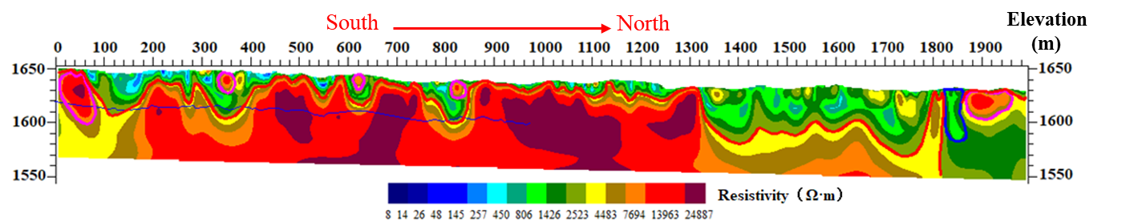
Figure 6: Resistivity distribution along the strike of F31 fault core
In sharp contrast to the 0~1320 m region (region A), the resistivity distribution in the 1320~1995 m region (region B) is characterized by low resistance values. This indicates that the fragmentation and looseness of overlying rocks in region B, due to the influence of strong weathering, shear or metamorphism, is higher than that in region A. It is worth noting that the resistivity distribution in region B is relatively continuous and consistent, and there is no obvious abnormal resistivity area in the relatively high resistance distribution area. This implies that the bedrock in region B is relatively complete, and there are no significant geological traces such as large faults or joints in the bedrock. Of course, we can intuitively observe that there is an obvious resistivity anomaly area at the border between region A and region B (i.e. X=1320 m), which shows a cliff-like jump in resistance value. Therefore, we can infer that a secondary fault tectonic movement occurred at this location, forming a secondary fault structure inside the F31 fault. This will provide a very important basis for subsequent fault stability analysis and water conductivity analysis of the fault zone.
Obviously, there are low resistivity responding areas with deep range influence degree in shallow surface regions, such as 100~200 m region, 300~400 m region and 780~840 m region. Through field investigation, we found that these low-resistance areas are mainly characterized by loose regolith composed of sand, gravel and silt, and shrub vegetation (Alhagi sparsifolia) exists in the regolith (Fig. 7). By removing some of the weathered surface with a shovel, it can be found that the sediment such as gravel and silt is relatively wet. Therefore, it can be inferred that the loose regolith may contain underground water and the underground water level is shallow. The presence of underground water within the regolith causes obvious low resistivity abnormal phenomena in the resistivity image.
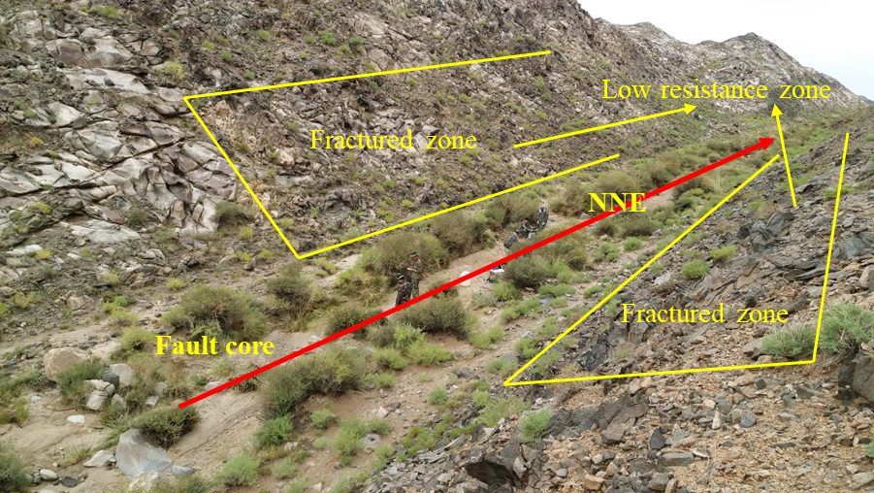
Figure 7: Field investigation of low resistance zones in F31 fault zone

Understanding the geological structure characteristics of the fault core and the fault-affected zone is also of great engineering geological value. This helps us to judge not only the width of the fault zone, but also the range of the fault damage zone. The inversion results of resistivity distribution of the detection line that was deployed perpendicular to the F31 fault core is shown in Fig. 8. From Fig. 8, on the resistivity spatial distribution profile, the resistivity distribution of rock mass in the detection area is dominated by high resistance value, while it is characterized by low resistance only in several local areas near the surface. Similarly, the reason for the existence of low resistivity area is due to weathering and metamorphism of rock masses within the surface. However, the resistivity distribution from east to west shows significant resistivity anomalies in X=140~200 m region (region C) and X=620~670 m region (region D). Combined with the location of the field survey line (Fig. 4), it can be determined that region C is the F31 fault zone, and the strong influence range of the fault zone is approximately 60 m. Another very important information we can get from Fig. 8 is that the width of the fault core is about 2~5m, and decreases with the increase of depth. Combined with the topographic features and the strike track of the fault, it can be judged from the resistivity distribution map that the strike of the fault is northwest and the average apparent dip angle is about 70° (namely, the fault dips about 70° NW). In particular, the orientation of the fault core is not constant, but the dip angle tends to slow down with the increase of buried depth. In the discussion section, we further discuss the ERT detection results in combination with an excavated prospecting trench.
In the shallow surface area within the range of X=200~460 m, the area with low resistivity distribution can be obviously observed. This is because the joints in this area are well developed and relatively broken due to the influence and control of the fault zone, and they are seriously weathered to form loose strata (or loose rock and soil) under the long-term geological process. This conclusion is also supported by the phenomenon of abundant vegetation growing in this area (Fig. 4b). What is worth paying attention to region D is that the resistivity distribution shows a sudden low value phenomenon, and the low value distribution range has a large radiation depth. Therefore, it is speculated that there may be a secondary fault zone in this region due to later geological activities. Even though the existence of this secondary fault has not been confirmed by drilling, ERT results also provide a very important reference value for further understanding the information of the hidden fault zone, and provide a necessary reference for subsequent drilling exploration and detection scheme planning.
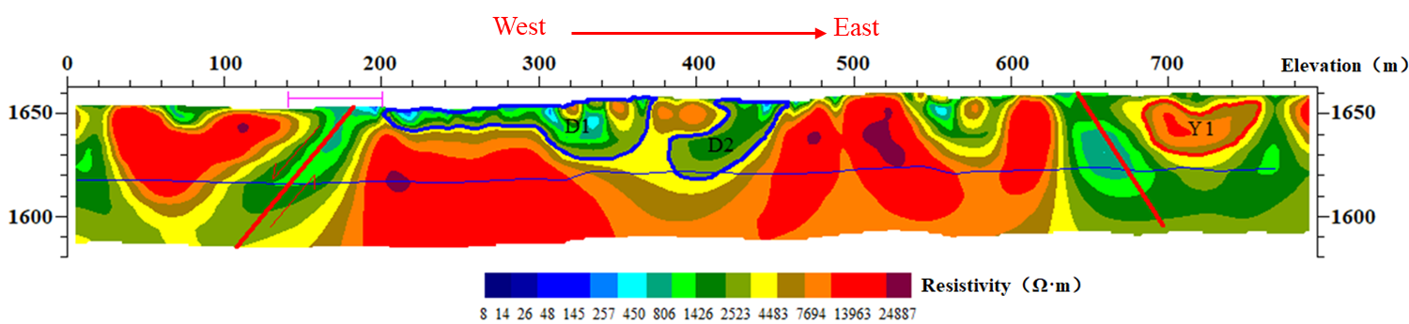
Figure 8: Resistivity distribution perpendicular to F31 fault

To further demonstrate the effect of ERT detection results and contribute to the intuitive cognition of the whole fault zone, we inversed the field data collected in F31 fault through advanced Geosciences, Inc. (AGI) software to obtain the three-dimensional inversion map of the detection area, and the results are shown in Figs. 9a and 9b. Based on the three-dimensional results, we can clearly grasp the geological structure characteristics of the fault zone through the form of section observation (Fig. 9c). Establishing a reasonable 3D resistivity distribution model from the detection data is still a challenging work, which is an important step towards a more comprehensive understanding of complex geological structures, and it is also the research we are committed to next.
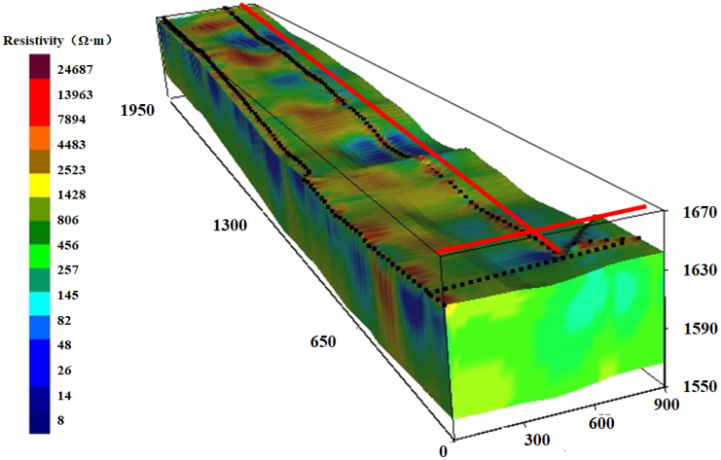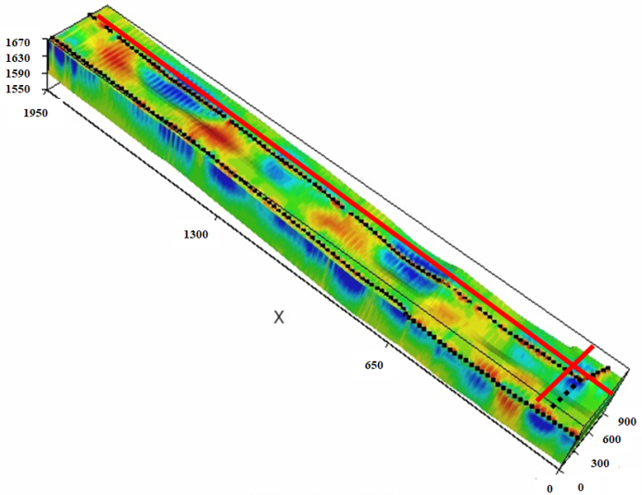
(b)
(a)
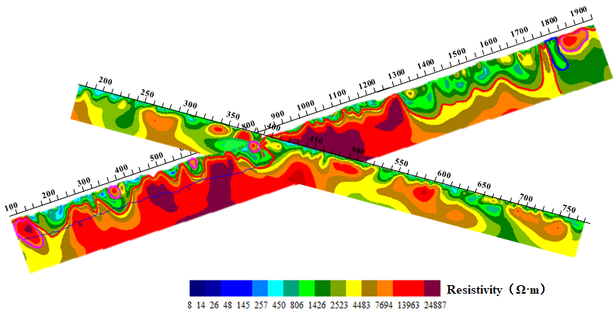
(c)
Figure 9: Three-dimensional inversion effect and fault zone resistivity distribution and section observation results. (a) and (b) are three-dimensional renderings of fault resistivity distribution; (c) A rendering of a cross-sectional observation.

4.2 RST results analysis
The surface wave velocity profile interpreted through the monitoring data of the two seismic detection lines are shown in Fig. 10. In general, the surface wave profile shows obvious wave resistance phenomenon, that is, the difference of stratum medium material leads to the difference of wave velocity. In the near-surface region, wave velocity distribution is generally low because of the loose soil formed by surface weathering, which obstructs wave transmission. However, some regions appear local wave velocity bulge jump phenomenon, especially the surface wave distribution of parallel to the F31 fault core (Fig. 10a). From Fig. 10a, the phenomenon of high wave velocity appears at X=160 m, X=370 m, X=460 m, X=500 m, X=630 m and X=660~670 m regions, etc., which indicates that these areas witnessed local compaction or bedrock up-inclination due to weathering deposition and geological movement. In addition, we can also conclude that on the surface wave distribution profile, 1000 m/s wave velocity is the boundary velocity, which represents the interface between the overlying weathered layer and the underlying bedrock. Fig. 10b shows the surface wave velocity distribution of the vertical F31 fault. From Fig. 10b, surface wave velocities remain almost uniformly distributed in the form of high velocities in the region below the weathered layer within the range of X = 0~160 m, indicating that the bedrock in this region is homogeneous. However, there is an obvious low-speed distribution in the X=150~200 m region. Combined with the layout of the field survey line, it can be determined that this region is the F31 fault zone with a width of approximately 50 m. Here, we also found that there are similarities and differences in the analysis of fault geological structures by using the two geophysical detection methods, which is explained in detail in the Discussion section.
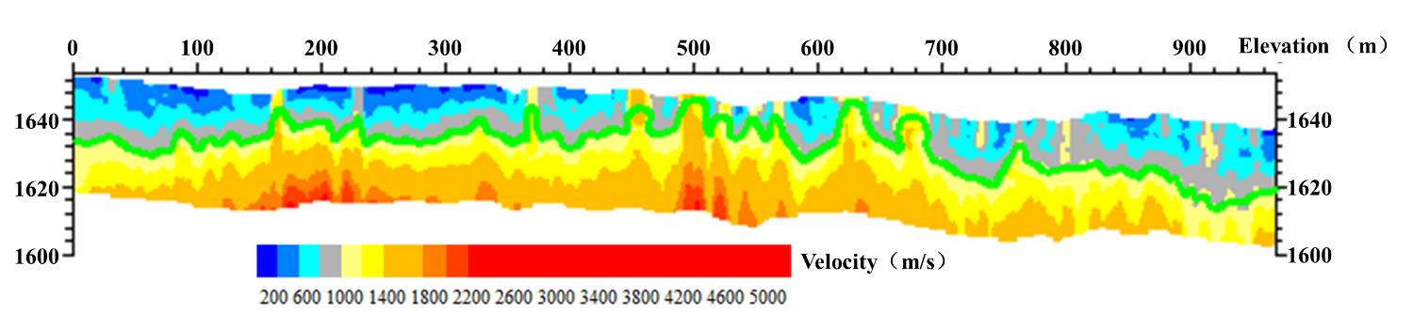
(a)
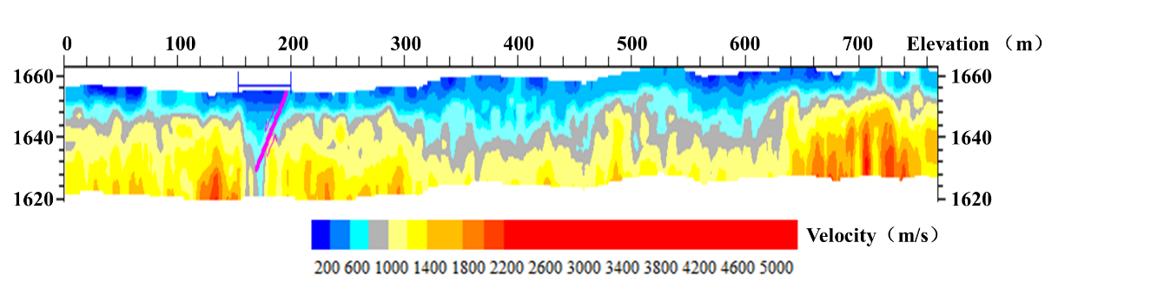
(b)
Figure 10: RST detection results parallel and perpendicular to F31 fault. (a) Detection result parallel to (or along) F31 fault strike; (b) Detection result perpendicular to F31 fault core.

5. Discussion

5.1 Reliability analysis of electrical measurement data
When using ERT technique to acquire raw data, the data actually collected are a series of current I values (mA) and potential difference ∆V values (mV) under different combination of measurement electrodes. Therefore, in the field measurement, it is inevitable to be interfered by various external factors, which makes the collected data have different degrees of error and causes uncertainty to the inversion results. Apparent resistivity, which can be calculated by the I value and ∆V value under different power supply conditions, is used to quantitatively analyze the quality of the obtained raw data. And the relative error calculation formula can be expressed as follows:
(1)
where ρ_{a1} and ρ_{a2} are the apparent resistivity values of the same measurement electrode combination at (400V, 50mV) and (400V, 10mV) supply parameters respectively.
The measurement data (including 1455 data points) of one detection station for the parallel F31 fault survey line and vertical F31 fault survey line were selected for analysis respectively. The error analysis results are shown in Fig. 11. From Fig. 11, the apparent resistivity obtained through the same electrode combination under different power supply parameters is not completely equal. For 1455 detection data points along the fault strike survey line, there are 10 data points with absolute relative error greater than 9%, accounting for about 0.7 % of the total data points. The absolute relative error of 15 data points is between 8% to 9%, accounting for about 1.0 %. The 57 data with an absolute relative error between 5% to 10% accounts for about 3.9%. Significantly, there are 1373 data points (the dotted line area in Fig. 11) with a relative error of less than +5%, which accounts for about 94.4% of the total. In terms of the measurement data of the vertical F31 fault detection line, there are 1385 data with relative error within + 5%, accounting for about 94.9% of the total data points. Therefore, we can conclude that in this field study, although there are some measurement data with error greater than +5% (data points with large error in subsequent processing can be eliminated as noise), the quality of measurement data, in general, is very high and reliable.
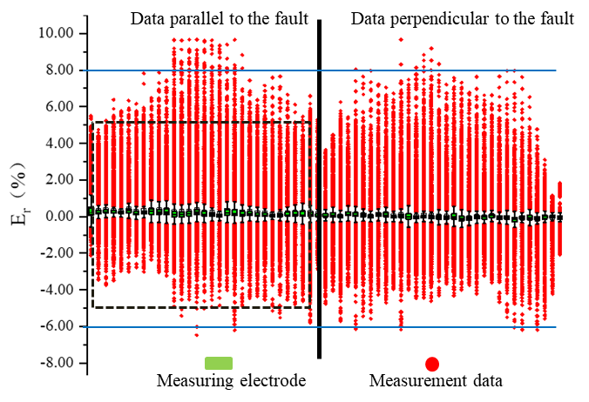
Figure 11: The relative error distribution of apparent resistivity obtained from two different supplying current conditions

5.2 Comparative analysis of geophysical interpretation results
To investigate the similarities and differences between the two geophysical methods (ERT and RST) in terms of detecting the F31 fault geological structure, we draw the high-density resistivity profile and seismic surface wave profile together in an equal proportion way. The comprehensive geophysical interpretation map is presented in the form of the main contours, as shown in Fig. 12. Fig. 12a shows the comprehensive geophysical results responding to the survey lines paralleling to F31 fault core, and Fig. 12b shows the results perpendicular to F31 fault. From Fig. 12a, combined with Figs. 6 and 10a, it can be concluded that the interface trend lines between shallow surface regolith and underlying bedrock are basically consistent within the common effective detection range (X=0~970 m) by using the two methods. Obviously, there are also four abnormal regions (Y1/Y2/Y3/Y4) in Fig. 12a, in which the interface determined by RST is higher than the result of ERT exploration. The reason for this difference is that the surface wave velocity increases locally due to the local solitary rock or tectonic movement compaction in the surface layer, which increases the high-speed layer in a certain range, leading to the inconsistency of the determined interface between the two methods.
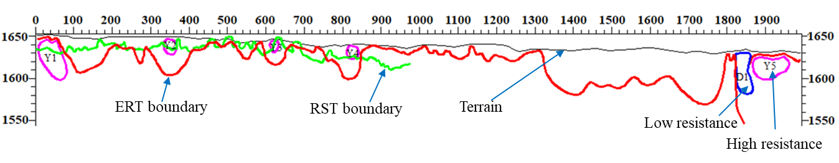
(a)
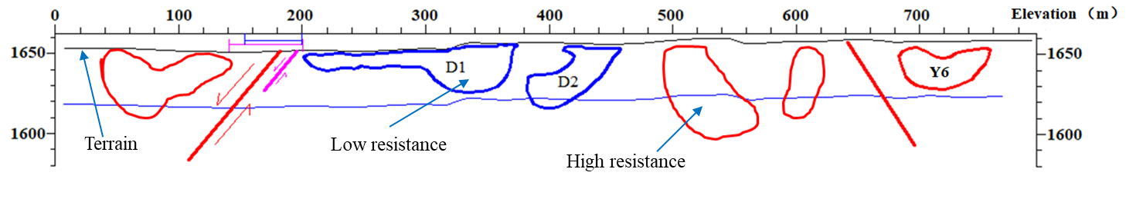
(b)
Figure 12: Comprehensive geophysical exploration results parallel and perpendicular to F31 fault. (a) Results parallel to the fault; (b) Results perpendicular to the fault.

In terms of the detection results perpendicular to the fault, the commonness and difference of the two geophysical exploration methods are more significant. Satisfactorily, both methods obtain the location of the F31 fault zone, with the 60-m long fault-affected zone detected by ERT and 50-m long fault-affected zone detected by RST (Fig. 12b). The reason for the 10-m difference may be the presence of boulders with high resistivity or shallow-buried bedrock in the area prior to X=160 m. The radiation depth of surface wave is shallow and the response of surface wave to shallow surface medium is obvious. When the heterogeneity of the detection area is significant and there is high wave velocity medium at the edge of the fault zone, the high wave velocity region will be wrongly extended due to the refraction effect of the wave, resulting in the deviation of the detection results. This conclusion is strongly supported by the phenomenon in the region of X=620~670 m. From Figs. 8, 10b and 12b, ERT results show that there is an obvious low resistivity abnormal area in this region, while RST results do not show the corresponding low velocity area. The resistivity results suggest that there are two obvious high-resistivity area in the shallow surface on both sides of the low-resistivity area. Surface waves generated in these high-resistivity area propagate to the low-resistivity area in a high energy (high wave velocity) manner, resulting in high wave velocity in the low resistance region.
Overall, both geophysical methods can detect complex underground geological structures. In contrast, ERT method, which is sensitive to the characteristics of complex media, has wide applicability to realize the fine detection of complex geological structures, while the detection results of RST make stern demands for the homogeneity and continuity of underground media.

5.3 Interpretation of fault core architecture
Through field investigation, we selected a heavily weathered area in the F31 fault core, and excavated a prospecting trench (with 1.3 m deep, 4.1 m long and 1.2 m wide) in the direction perpendicular to the F31 fault strike (Fig. 13a). The walls of the prospecting trench were carefully cleaned with a brush to reveal the geological features of the fresh fault core. From Fig. 13a, the main traces of the fault can be observed after the weathered quaternary stratum in the surface was stripped for 1m. According to the geological information revealed by the three-dimensional prospecting trench, the revealed zone can be divided into three parts: i) hanging wall fractured zone (mainly characterized by crushed rock fragments with the size of 2~10 cm (see Fig. 13b)), ii) crushed grave mixed with fault gouge zone (mainly characterized by small rock fragments with the size of 1~10 mm and compacted mud (see Fig. 13c)) and iii) footwall fractured zone (mainly characterized by rock fragments with the size of 5~15cm). As a result, the central area of the F31 fault core is most seriously broken due to tectonic stress and weathering, the length in the prospecting trench is approximately 2.6 m (Fig. 13a). It is particularly noteworthy that the existence of fault gouge in the fault core makes the permeability of this area very low, which is significantly lower than that of the surrounding fractured zone. In addition, through the information revealed by the prospecting trench, we can also conclude that the fragmentation degree of the hanging wall rock mass (0.9 m) at the F31 fault core is higher than that at the footwall (0.6 m), which also proves that F31 fault belongs to the category of normal fault. Both sides of the fractured zone are fractured damage zones. This is basically consistent with the geophysical detection result (fault core length is 2~5 m). Although the cataclastic rocks near the fault core are greatly damaged, they can still interpret the orientation information in the traces of fault activity. The orientation of discontinuities at the fault core was measured to be 280°∠75° by using a geological compass, which proves the reliability of detecting fault geological structure by using ERT method (the fault dips about 70° NW).
(a)
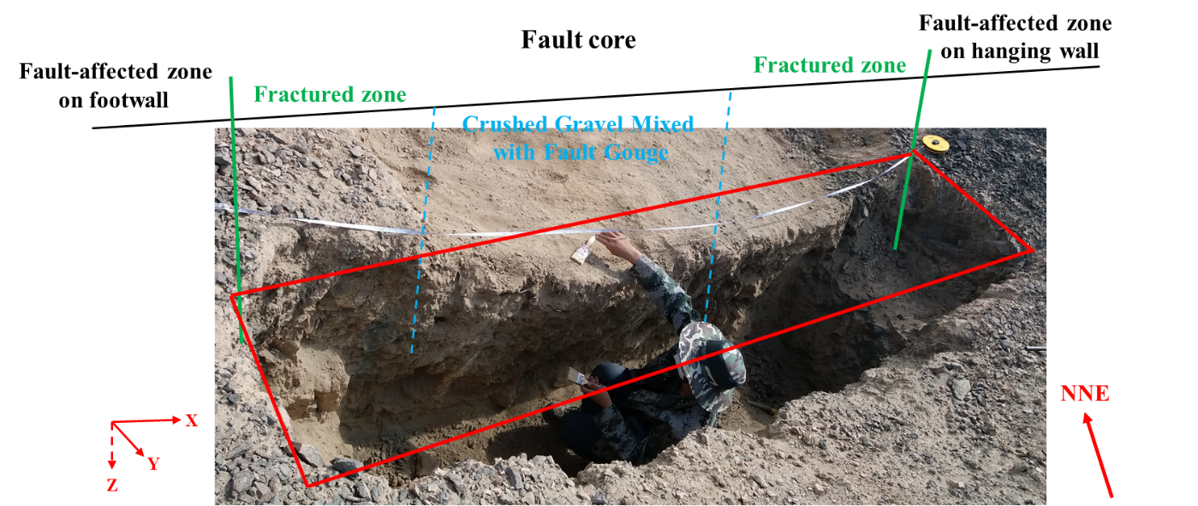
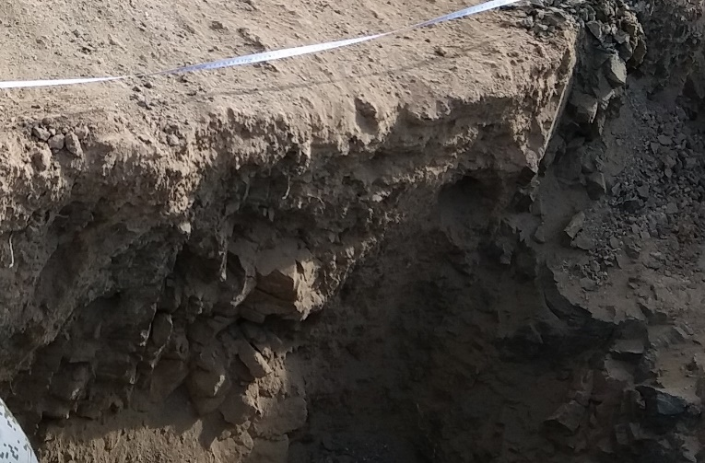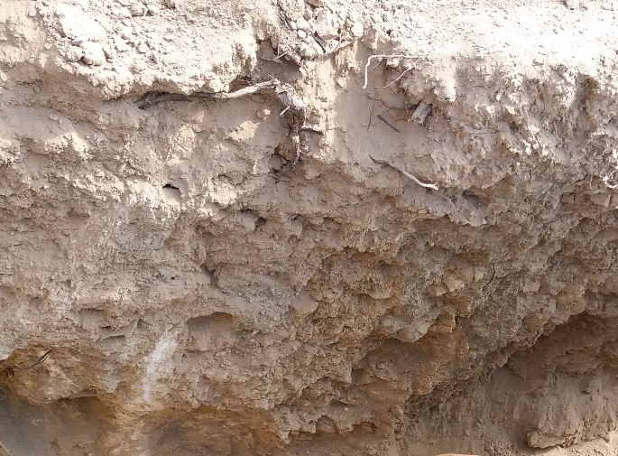
(c)
(b)
and breccia
Crushed gravel
Fault gouge
Ctaclastic rocks
Discontinuity
Figure 13: The prospecting trench excavated at the F31 fault core and parts of geological information revealed inside the fault. (a) The excavated exploratory/prospecting trench; (b) Lithological characteristics of hanging wall of the fault core; (c) Lithological characteristics of fault core.

6. Conclusions
In this paper, we used the high-density electrical resistivity tomography and reflection seismic tomography techniques to detect and describe the subsurface architecture of the km-scale F31 fault in the candidate site of the Beishan high level radioactive waste geological disposal repository. Combined with the geological structure information of the fault zone revealed by an excavated trench at the fault core, the validity of the geophysical interpretation results was discussed, and the internal structure characteristics of the fault zone were finely explained. Important conclusions are as follows:
- ERT technique can clearly reflect the geoelectric response characteristics of the underground complex geological structure through the captured F31 fault zone resistivity distribution, which indicates that ERT is feasible for in-situ geological exploration and measurement under large-scale and complex conditions. As an important supplement to surface survey and borehole survey, ERT can provide valuable and necessary information for researchers to understand underground structures.
- In the resistivity images obtained by ERT, the rock mass is generally characterized by a continuous spatial distribution of high resistivity, while the geological traces such as faults, fractures and weathered strata are characterized by low or relatively low resistivity, which forms obvious resistivity differences with surrounding rock masses. As a result, the weathering damage degree in the northern part of the F31 fault is much larger than that in the southern part of the fault; moreover, the resistivity in terms of the bedrock below the weathering-affected layer in the F31 fault zone is relatively continuous and consistent in spatial distribution in the form of high values, indicating that the bedrock within the F31 fault is relatively complete and there is no obvious secondary tectonic movement or fault in the fault zone.
- For the direction perpendicular to the fault core, the width of the strong damage zone affected by the fault core is about 60 m using ERT, while the RST result is approximately 50 m, which are basically the same. However, at the position about 400 m away from the fault core on the hanging wall of the fault, the ERT results also clearly diagnosed that there may be a secondary small fault here. To determine whether there exists the potential fault, further investigation and detection scheme are, of course, needed in the next research.
- Combined with the observation results from prospecting trench and the ERT results, the width of the F31 fault core at the detection area can be determined to be approximately 2.6 m, which is mainly characterized by crushed gravel (or/and breccia) mixed fault gouge. It should be noted that the fault gouge existing in the fault core zone is in a compacted state through on-site observation, and it is speculated that fault gouge may have a certain water blocking effect. The core zone is flanked by the damage zone where the rock is sheared to form massive catastrophic rocks. The discontinuity orientation measured at the junction of the two places is about 280°∠75°, which is highly consistent with the interpretation result by using ERT (the fault dips about 70° NW). Overall, the transverse section of F31 fault can be considered to be mainly composed of three architectural elements, including core zone, damage zone and protolith zone.

Declaration of Competing Interest
There are no known conflicts of interest associated with this publication.

Acknowledgements
The authors gratefully acknowledge support from the National Key Research and Development Project of High-level Radioactive Waste Disposal of China (2020-194). The support received for this project from the Beijing Research Institute of Uranium Geology is greatly appreciated.

References
Bonson, C.G., Childs, C., Walsh, J.J. et al. (2007). Geometric and kinematic controls on the internal structure of a large normal fault in massive limestones: The Maghlaq Fault, Malta. Journal of Structural Geology, 29(2), 336-354
Caine, J.S., Evans, J.P., and Forster, C.B. (1996). Fault zone architecture and permeability structure. Geology, 24(11), 1025-1028.
Chen, C.W., Sato, M., Yamada, R., et al. (2022). Modeling of earthquake-induced landslide distributions based on the active fault parameters. Engineering Geology, 106640.
Cochran, E.S., Li, Y.G., Shearer, P.M., et al. (2009). Seismic and geodetic evidence for extensive, long-lived fault damage zones. Geology, 37(4), 315-318
Fang, Y., Elsworth, D., Wang, C., et al. (2018). Mineralogical controls on frictional strength, stability, and shear per-meability evolution of fractures. Journal of Geophysical Research: Solid Earth, 123, 3549– 3563.
Faulkner, D.R., Lewis, A.C., and Rutter, E.H. (2003). On the internal structure and mechanics of large strike-slip fault zones: field observations of the Carboneras fault in southeastern Spain. Tectonophysics, 367(3-4), 235-251.
Faulkner, D.R., Mitchell, T.M., Healy, D., et al. (2006). Slip on'weak'faults by the rotation of regional stress in the fracture damage zone. Nature, 444(7121), 922– 925.
Fialko, Y., and Jin, Z. (2021). Simple shear origin of the cross-faults ruptured in the 2019 Ridgecrest earthquake sequence. Nature Geoscience, 14(7), 513-518.
Graham, B., Antonellini, M., and Aydin, A. (2003). Formation and growth of normal faults in carbonates within a compressive environment. Geology, 31(1), 11-14.
Hardebeck, J.L., and Hauksson, E. (1999). Role of fluids in faulting inferred from stress field signatures. Science, 285(5425), 236– 239.
Ho, G.R., Chang, P.Y., Lee, J.C., et al. (2020). Surface traces and related deformation structures of the southern Sanyi Fault, Taiwan, as deduced from field mapping, electrical-resistivity tomography, and shallow drilling. Engineering Geology, 273, 105690.
Ishibashi, M., Yoshida, H., Sasao, E., and Yuguchi, T. (2016). Long term behavior of hydrogeological structures associated with faulting: An example from the deep crystalline rock in the Mizunami URL, Central Japan. Engineering geology, 208, 114-127.
Ishii, E. (2017). Preliminary assessment of the highest potential transmissivity of fractures in fault zones by core logging. Engineering Geology, 221, 124-132.
Ishii, E. (2021). The highest potential transmissivities of fractures in fault zones: Reference values based on laboratory and in situ hydro-mechanical experimental data. Engineering Geology, 294, 106369.
Kneuker, T., Hammer, J., Shao, H., et al. (2017). Microstructure and composition of brittle faults in claystones of the Mont Terri rock laboratory (Switzerland): New data from petrographic studies, geophysical borehole logging and permeability tests. Engineering Geology, 231, 139-156.
Lesage, G., Byrne, K., Morris, et al. (2019). Interpreting regional 3D fault networks from integrated geological and geophysical data sets: An example from the Guichon Creek batholith, British Columbia. Journal of Structural Geology, 119, 93-106.
Long, J.J., and Imber, J. (2012). Strain compatibility and fault linkage in relay zones on normal faults. Journal of Structural Geology, 36, 16-26.
Ma, X., Hertrich, M., Amann, F., Bröker, K., et al. (2022). Multi-disciplinary characterizations of the BedrettoLab–a new underground geoscience research facility. Solid Earth, 13(2), 301-322.
Odling, N. E., Harris, S. D., and Knipe, R. J. (2004). Permeability scaling properties of fault damage zones in siliclastic rocks. Journal of Structural Geology, 26(9), 1727– 1747.
Renard, P., and De Marsily, G. (1997). Calculating equivalent permeability: a review. Advances in water resources, 20(5-6), 253-278.
Rupnik, P. J., Žebre, M., Jež, J., et al. (2022). Deciphering the deformation mechanism in Quaternary deposits along the Idrija Fault in the formerly glaciated Soča Valley, southeast European Alps. Engineering Geology, 106515.
Sapia, V., Villani, F., Fischanger, F., et al. (2021). 3D deep electrical resistivity tomography of the major basin related to the 2016 Mw 6.5 central Italy earthquake fault. Tectonics, 40(4), e2020TC006628.
Schulz, S.E., and Evans, J.P. (2000). Mesoscopic structure of the Punchbowl Fault, Southern California and the geologic and geophysical structure of active strike-slip faults. Journal of Structural Geology, 22(7), 913-930.
Shipton, Z. K., and Cowie, P. A. (2001). Damage zone and slip-surface evolution over μm to km scales in high-porosity Navajo sandstone, Utah. Journal of Structural Geology, 23(12), 1825-1844.
Smith, S.A., Bistacchi, A., Mitchell, T.M., et al. (2013). The structure of an exhumed intraplate seismogenic fault in crystalline basement. Tectonophysics, 599, 29-44.
Štěpančíková, P., Dohnal, J., Pánek, T., et al. (2011). The application of electrical resistivity tomography and gravimetric survey as useful tools in an active tectonics study of the Sudetic Marginal Fault (Bohemian Massif, central Europe). Journal of Applied Geophysics, 74(1), 69-80.
Valoroso, L., Chiaraluce, L., and Collettini, C. (2014). Earthquakes and fault zone structure. Geology, 42(4), 343-346.
Wang, J., Chen, L., Su, R., and Zhao, X. (2018). The Beishan underground research laboratory for geological disposal of high-level radioactive waste in China: planning, site selection, site characterization and in situ tests. Journal of Rock Mechanics and Geotechnical Engineering, 10(3), 411-435.
Wang, X., Crosta, G.B., Clague, J.J., et al. (2021). Fault controls on spatial variation of fracture density and rock mass strength within the Yarlung Tsangpo Fault damage zone (southeastern Tibet). Engineering Geology, 291, 106238.
Wu, H., Huang, Z., and Zhao, D. (2021). Deep structure beneath the southwestern flank of the Baikal rift zone and adjacent areas. Physics of the Earth and Planetary Interiors, 310, 106616.
Xu, W., Zhang, Y., Li, X., et al. (2020). Extraction and statistics of discontinuity orientation and trace length from typical fractured rock mass: A case study of the Xinchang underground research laboratory site, China. Engineering Geology, 269, 105553.
Xu, W., Zhang, Y., Li, X., et al. (2021). Comprehensive identification of statistical homogeneity of fractured rock masses for a candidate HLW repository site, China. Engineering Geology, 293, 106279.
Zhang, M., Ge, S., Yang, Q., and Ma, X. (2021). Impoundment-Associated Hydro-Mechanical Changes and Regional Seismicity Near the Xiluodu Reservoir, Southwestern China. Journal of Geophysical Research: Solid Earth, 126(9), e2020JB021590.
Zhang, S., and Ma, X. (2021). How does in situ stress rotate within a fault zone? Insights from explicit modeling of the frictional, fractured rock mass. Journal of Geophysical Research: Solid Earth, 126(11), e2021JB022348.

