A novel fdemi device for detecting permafrost using an active bucking system
Michele Maxson, Cold Regions Research and Engineering Laboratory, Hanover, NH, USA
David Lozano, Cold Regions Research and Engineering Laboratory, Hanover, NH, USA
Dr. Mikheil Prishvin, Subsurface Sensing Technologies, Tbilisi, Georgia
Dr. Benjamin Barrowes, Cold Regions Research and Engineering Laboratory, Hanover, NH, USA
Dr. Fridon Shubitidze, Dartmouth College, Hanover, NH, USA

Abstract
The iFROST system is a lightweight, frequency domain electromagnetic induction (FDEMI) system designed using a novel active bucking system with the purpose of detecting the depth of the active layer. Here, the active layer is defined as the portion of the ground above permafrost that freezes and thaws annually. This paper presents a subset of our preliminary results from iFROST data collected in Fox, Alaska, USA over different active layer thicknesses. The iFROST system incorporates a novel, active bucking system and can currently be tuned to acquire data at two frequencies, 93kHz (presented in this paper) and 330kHz. A non-conductive test rig was designed to acquire data from the system from 0 to 2 meters in 10cm increments. This was done to test the system response’s stability and provide high quality datasets for developing advanced 3-D physics-based inversion methodologies. Using the GEM2 system by Geophex, which also operates at 93 kHz, data was collected at identical locations in Alaska for comparison with the iFROST data to show the sensitivity of the iFROST system. The results from this testing shows that the novel, active bucking system provides a new way to minimize the primary field in the receiver coil of the sensor without having to calibrate the system in a laboratory setting. This active bucking configuration works in standard field conditions and provides a stable, predictable response which can be used for inversion procedures.

Introduction
Permafrost is defined as frozen soil that remains continuously frozen for at least two consecutive years. Regions which contain permafrost cover approximately 25% of the Northern Hemisphere. One impact of climate change is the accelerated thawing of the permafrost, with regions north of the Arctic Circle warming twice as fast as the rest of the globe [1]. In addition to the global implications of thawing permafrost, negative impacts at the local scale are realized in the design and maintenance of civil infrastructure. As such, there is a need to develop effective, efficient, and cost-effective permafrost mapping technologies. Several subsurface sensing techniques, such as GPR, low frequency electromagnetic induction, and magneto telluric methods, have been developed to meet this challenge [4] [5] [6] [7]. However, these methods are either costly to deploy, are overly sensitive to changing environmental conditions, or do not provide the resolution required for vertical and horizontal infrastructure design work. Here we present results from the developmental In-Flight Rapid Observation and Survey Tool (iFROST) [8] [9] [10]. The iFROST is a light weight, easy deployment system, which uses tuned frequency domain electromagnetic transmitters and a novel active bucking system for the detection of permafrost. This paper shows preliminary data collected at 93kHz from both the iFROST system and the Geophex GEM2 in areas with permafrost. The GEM2 is the only commercially available, handheld system which also operates at a comparable frequency which is why this sensor is used for comparison.
Methods
Data collection
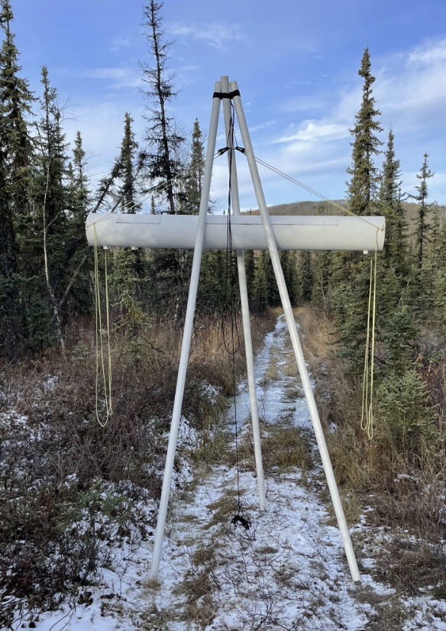
Data was collected at six (6) locations near the ERDC Cold Regions Research and Engineering Laboratory’s Permafrost Tunnel in Fox, Alaska. Permafrost thaw occurs both vertically and laterally, where vertical thaw is indicated by changes in the active layer depth and lateral thaw results in discontinuous permafrost layers. The active layer refers to the region between the ground surface and top of the permafrost where seasonal thaw occurs. The data presented in this paper represents two of the six locations and is designed to investigate the vertical thaw. Location 3 is at the intersection of two trails and is known to have a thicker active layer due to the heavy usage of the trail (i.e depth to permafrost is nearly 3 meters). Location 5 is on a small footpath approximately 30 meters from location 3, with a depth to top of permafrost of approximately 0.8 meters, which more closely represents the active layer thickness for the area. Depths were determined from a combination of electrical resistivity tomography and physical probe measurements.
The test rig is designed using three, 10 foot, PVC poles connected at the top using nylon cord. The system is hung from the test rig and is lowered in 10-centimeter increments by increasing the length of cord between the top of the rig and the system as seen in Figure 1. Prior to elevations measurements, background data and ferrite checks were completed. The resulting signal for the ferrite checks has the expected real and imaginary averages and no noticeable drift.
Figure 1: iFROST system mounted in test rig.

Data processing
The iFROST system can store a maximum of 2¹⁴ (16384) values in memory and the FPGA samples the waveform(s) at a maximum rate of 125Msamples/sec. The system is designed to sample the f = 93kHz waveform at a rate of 7.8125 Msamples/sec resulting in approximately 195 waveforms being sampled. Both the received signal and transmitted signals are sampled. Each sample, X_{i}, is stored as a voltage in memory. The first step in data processing is to convert the sampled data into a single data point, D, with a real (R) and imaginary (I) component, also known as the in-phase and quadrature components (equations 1-3 below).

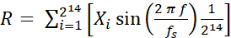 (1)
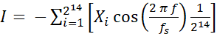 (2)
(3)

The received data, D_{rx}, was then normalized by the transmitted data, D_{tx}, to compensate for any fluctuations in the output signal resulting in a normalized dataset, D_{n}. Finally, the background and ferrite corrections were applied to the data as seen below in equations 4-6.

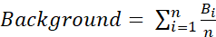 (4)
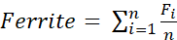 (5)
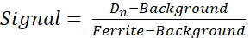 (6)

Results
The iFROST system is designed to collect 50 data points whereas the GEM2 sensor continuously collects data. Therefore, approximately 10-15 seconds of data was collected by the GEM2 sensor at each elevation resulting in 600-1500 data points. Fifty (50) of the central most points were used in the comparison to avoid early and late data points where the user was in the field to turn on and off the GEM2 sensor. The GEM2 calibration was verified using the “free air calibration technique” outlined in the manual [12] and processed using Geophex’s proprietary software, GEM2Export. The quadrature results for the GEM2 data are used in this paper. During data collection, GEM2’s seven (7) default frequencies were collected, but this paper focuses on the highest frequency, 93kHz, because iFROST also collects data at 93kHz. The average response from iFROST at the height which the system was nulled is subtracted from corresponding data collected at other heights. Similarly, the average response from the maximum height at which the GEM2 data was collected was also subtracted from corresponding data collected at other heights. This was to compensate for the response of the ground that was removed from the data during bucking. The responses from the two sensors are recorded on different scales, therefore, each set of data was divided by the maximum response from the corresponding dataset. This scaled both systems between 0-1 allowing side-by-side comparisons.
Data was collected at the two different locations with both sensors. 50 data points from the iFROST and 50 data points from the GEM2 as well as their average values are seen below in Figure 2.

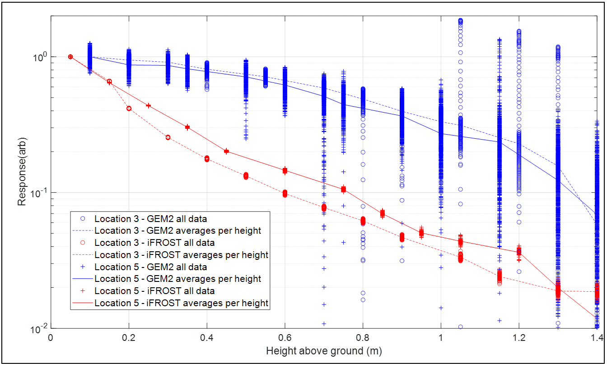
Figure 2: iFROST and GEM2 data over locations 3 and 5.
The spread of the GEM2 is larger than the iFROST system for the elevations and frequency at which was tested. As the height above ground increases, the spread of the data from both systems also increases. This is to be expected since the signal to noise ratio decreases with height for both systems. The iFROST data shows different slopes for different sections of the elevation data. The different trends in the elevation curve for the iFROST system may provide additional information that can be used during the inversion process. Overall, the iFROST system has a predictable response. Using the 93kHz data as validation for the sensor, it is anticipated that different frequencies may have higher resolution in the near surface where the boundary for the active layer and permafrost exists.

Conclusions
Several subsurface sensing techniques have been developed to meet the challenge of mapping permafrost such as GPR, low frequency electromagnetic induction, and magneto telluric methods. These methods still have inherent challenges including cost, resolution, and ease-of-use. This paper presented the In-Flight Rapid Observation Surveying Tool (iFROST), a frequency domain electromagnetic induction sensor with a novel active bucking system which is lightweight enough to mount on a UAS. Further, this paper compared results from elevation testing from a commercially available sensor, Geophex’s GEM2, as a reference to the iFROST system in an area with known permafrost. The comparison of the two sensors showed that the response from the iFROST system was predictable and creates high-quality datasets. It should be noted that the GEM2 operates at several frequencies ranging from 200Hz to 93kHz, therefore, the GEM2 is operating at the highest designed frequency. Often, electromagnetic induction sensors which are operated at the extremes of their design capabilities can be less predictable. Other GEM2 frequencies may have a different spread at these heights, but the resolution in the near surface of lower frequencies is expected to be too poor for the purpose of permafrost detection. Near future work with the iFROST system will include the evaluation of the system over the same locations presented in this paper at 330kHz and the remaining GEM2 default frequencies (210Hz, 690Hz, 2.43kHz, 8.13kHz, 27.5kHz, and 63kHz). Future work still needs to be completed to compare layered models with known conductivity values to the resulting datasets. This work will be used to inform the development of physics based 3-D inversion methodologies.

References

[1] | National Oceanic and Atmospheric Administration, "The changing Arctic: A greener, warmer and increasingly accessible region," 15 December 2017. [Online]. Available: https://www.noaa.gov/explainers/changing-arctic-greener-warmer-and-increasingly-accessible-  region#:~:text=Unlike%20snow%20and%20ice%20which%20reflect%2070%20percent,stream  %2C%20a%20major%20driver%20of%20global%20weather%20patterns.. [Accessed 6 June 2022].
[2] | J. Abraham, "A promising tool for subsurface permafrost mapping—An application of airborne geophysics from the Yukon River Basin, Alaska: Fact Sheet 2011-3133," U. S. Geological Surve, 2011.
[3] | S. Arcone, D. Lawson, A. Delaney, J. Strasser and J. Strasser, "Ground-penetrating radar reflection profiling of groundwater and bedrock in an area of discontinuous permafros," Geophysics, vol. 63, no. 5, pp. 1573-1584, 1998.
[4] | B. Dafflon, S. S. Hubbard, C. Ulrich and J. E. Peterson, "Electrical conductivity imaging of active layer and permafrost in an arctic ecosystem, through advanced inversion of electromagnetic induction data," Vadose Zone Journal, vol. 12, no. 4, pp. 1-19, 2013.
[5] | T. A. Douglas, M. T. Jorgenson, D. R. N. Brown, S. W. Campbell, C. A. Hiemstra, S. P. Saari, K. Bjella and A. K. Liljedahl, "Degrading permafrost mapped with electrical resistivity tomography, airborne imagery and LiDAR, and seasonal thaw measurements," Geophysics, vol. 81, p. WA71–WA85, 2016.
[6] | B. Barrowes, D. Glaser, M. Prishvin, M. Coleman and F. Shubitidze, "Assessing the Frozen State of Soils Using iFrost: An Electromagnetic Induction Sensor on a UAS Platform," Cold Regions Engineering, pp. 8-16, 2019.
[7] | M. Maxson, D. Lozano, B. Barrowes and F. Shubitidze, "Active Bucking using a System on a Chip Field Programmable Gate Array for Geophysical Investigationa," in Symposium on the Application of Geophysics to Engineering and Environmental Problems, New Orleans, LA, 2023.
[8] | M. Maxson, T. Shubitidze, M. Prishvin, B. Barrowes, B. Quinn, R. Reynolds, D. Lozano and F. Shubitidze, "Preliminary Data from the In-Flight Rapid Observation and Surveying Tool (iFROST) for EMI Mapping Permafrost," in Symposium on teh Application of Geophyiscs to Engineering and Environmental Problems, Denver, CO, 2022.
[9] | Geophex, Ltd, "GEM-2 Manual," Geophex, Ltd, Raleigh, 2004.
[10] | M. C. Serreze and R. Barry, "Processes and impacts of Arctic amplification: A research synthesis," Global and Planetary Change, vol. 77, no. 1-2, pp. 85-96, 2011.
[11] | R. G. Graversen, T. Mauritsen, M. Tjernstrom, E. Kallen and G. Svensson, "Vertical structure of recent Arctic warming," Nature, vol. 451, pp. 53-56, 2008.
[12] | S. H. Ward, G. W. Hohmann and M. N. Nabighian, "Electromagnetic methods in applied geophysics," Tulsa, Oklahoma, USA, vol. 1, p. 131–312, 1988.
[13] | H. Huang, "Depth of investigation for small broadband electromagnetic sensors," Geophysics, vol. 70, p. G135–G142, 2005.
[14] | Geometrics, "MagArrow UAS Depolyable Magnetometer," January 2022. [Online]. Available: https://www.geometrics.com/wp-content/uploads/2022/01/MagArrow_Spec_Sheet.pdf. [Accessed 7 June 2022].
[15] | Fugro Airborne Surveys, "Logistcs and Processing Report Airborne Magnetic and Resolve Survey; Fort Yukon Area, Alaska and Fort Wainwright HEM Lines," 2010.

